Name:konyala sai vardhan reddy
Student id: 700745733.
Github link: https://github.com/vardhan141/CS5710-In-Class-Programming-Assignment-2
Recorded video link: https://drive.google.com/file/d/11oshMiLhZ5chDf-Sig8a3HoDWJgkzd40/view?usp=sharing
Program 1:
Printing the given pattern
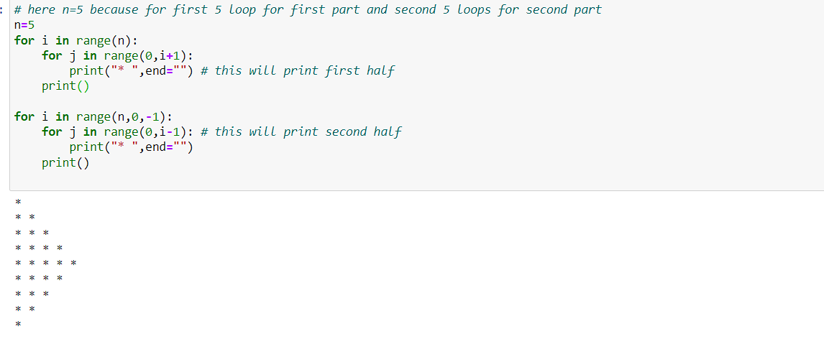
Program 2:
Use looping to output the elements from a provided list present at odd indexes.
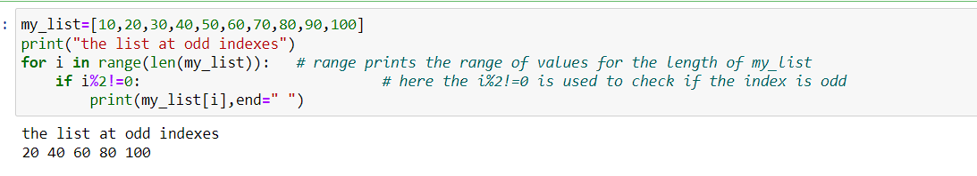
Program 3:
Write a code that appends the type of elements from a given list.
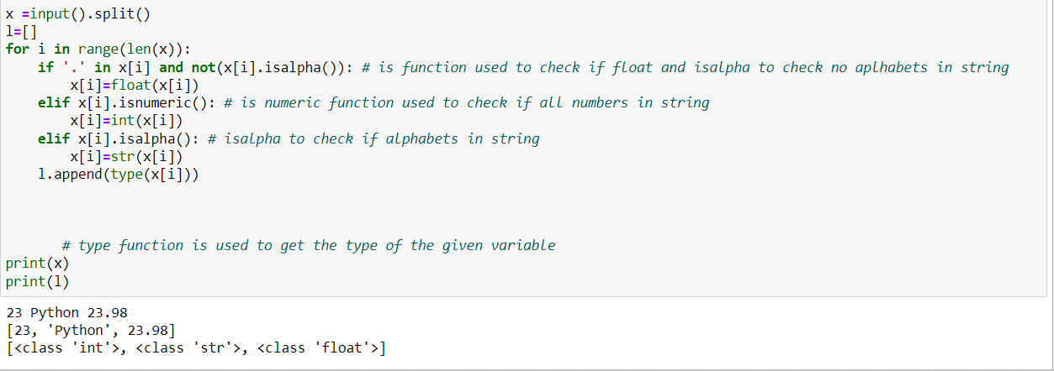
4. Write a function that takes a list and returns a new list with unique items of the first list.
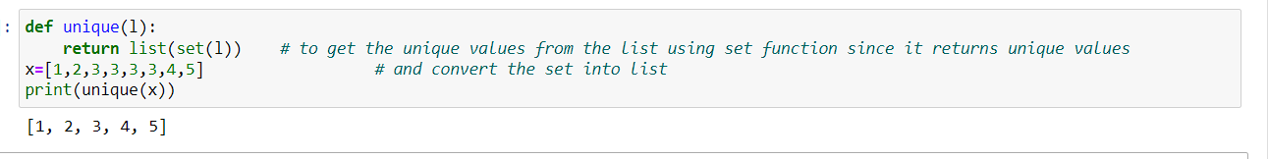
5. Write a function that accepts a string and calculate the number of upper-case letters and lower-case letters.
